1. **Study and Working of WEKA TOOL**

**Steps:**

a)Download Weka 3.8.4 and install the program.

b) Open WEKA GUI chooser and select “**Explorer**”.



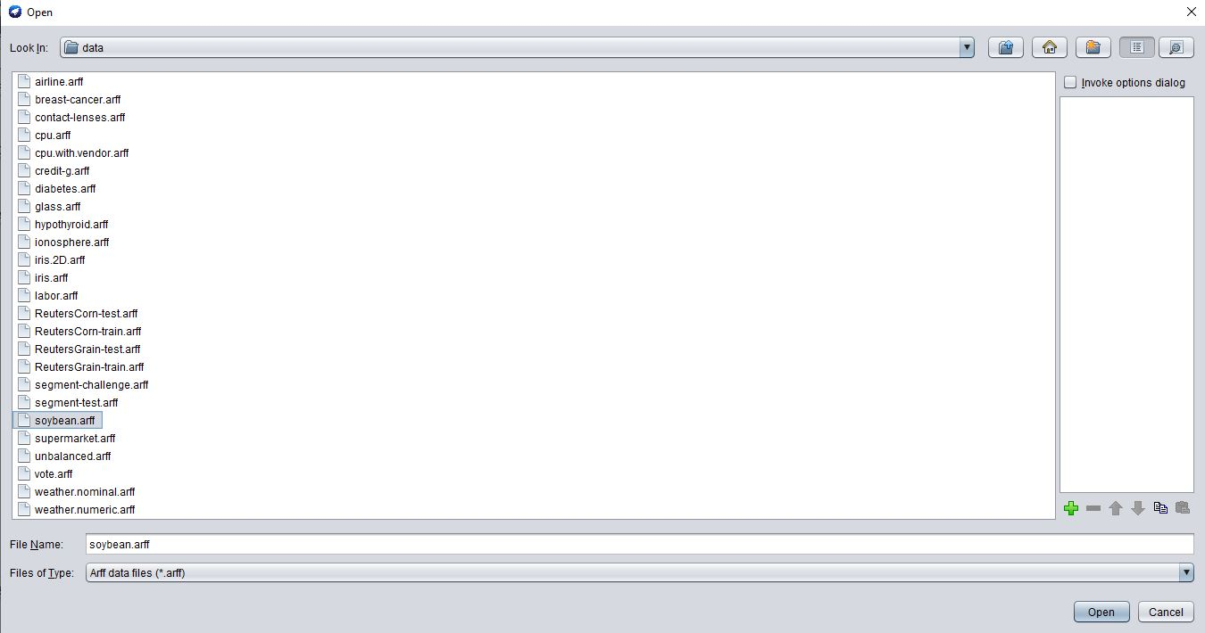c) We can select sample file provided with WEKA. For that, select open file and browse to location C:\Program Files\Weka-3-8-4\data.

d) Open any file with .arff extension. Here, I’ve used soybean.arff.

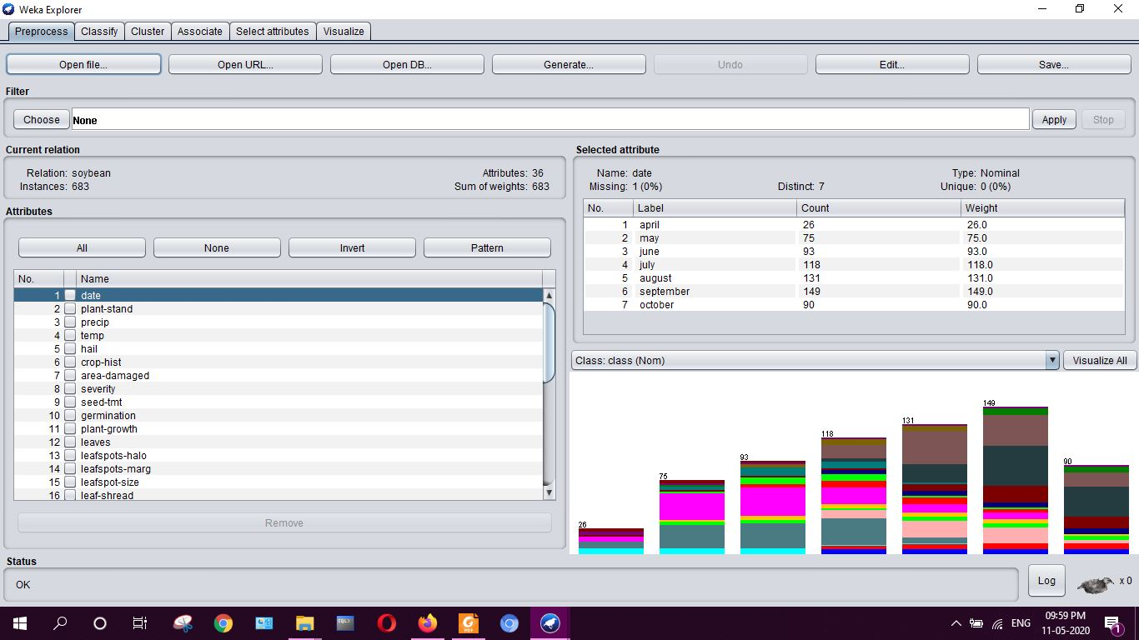

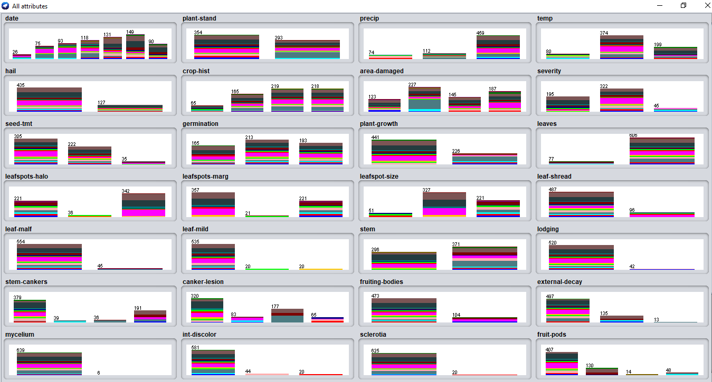e) Select “Visualize all” to check all the attributes.

f) Go to “**Classify**”, choose a classifier J48 from trees and select “start”.

g) Classifier output:

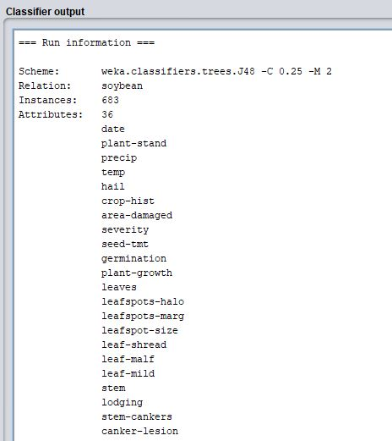

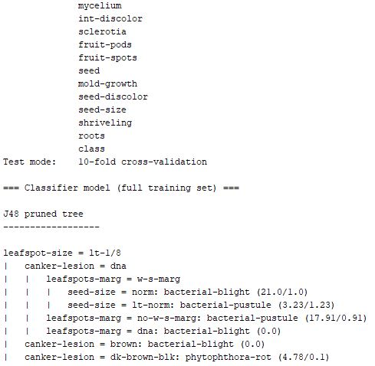

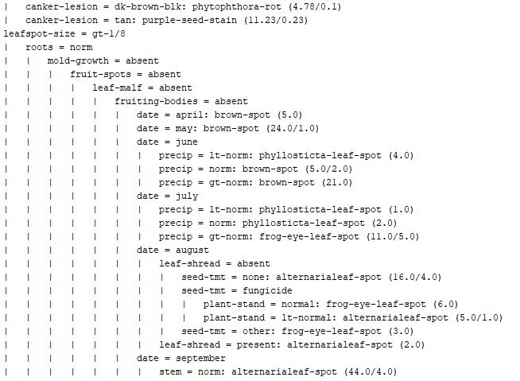

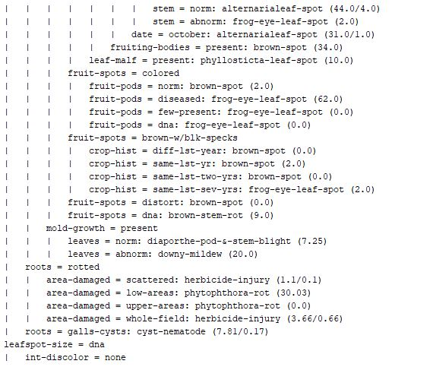

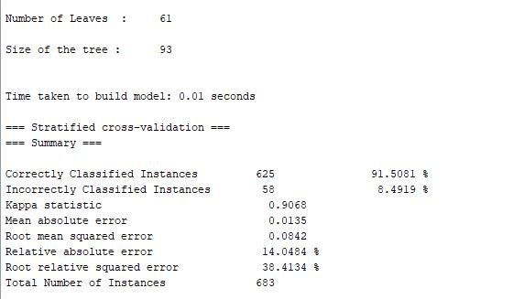

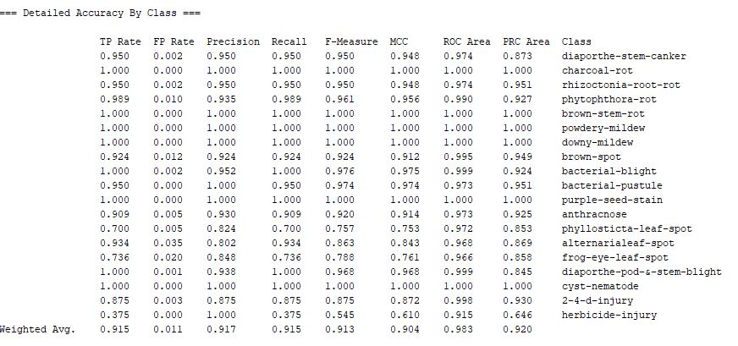

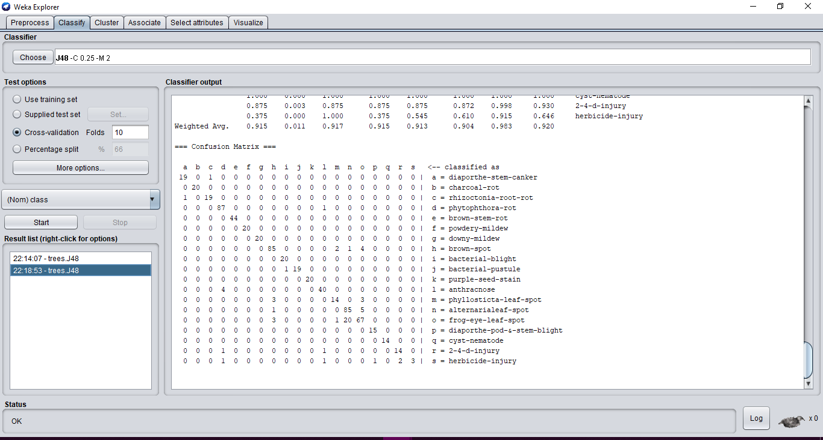

This will classify the dataset and create a ‘confusion matrix’. It the dataset and classification is proper, an “OK” status will appear in the bottom left corner.

g) we can visualise the tree by choosing visualize tree option which is a Weka classifier tree visualiser. This gives a brief idea on how classification is done.

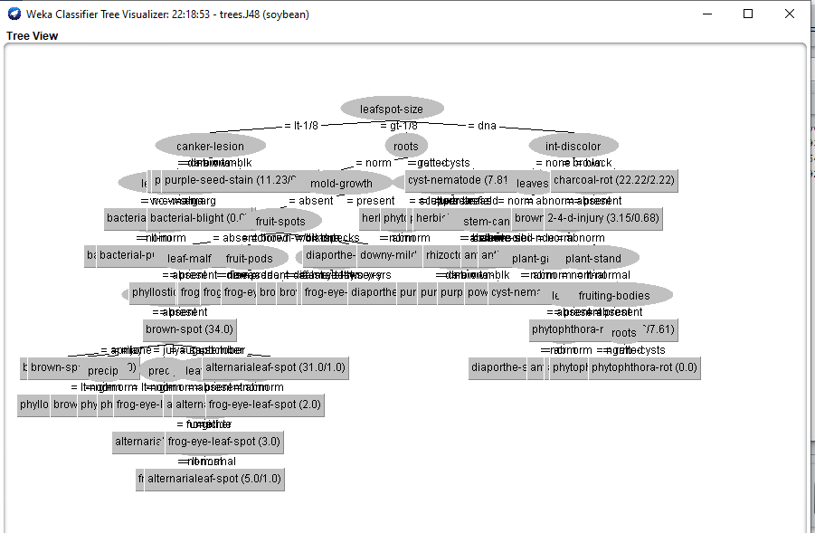

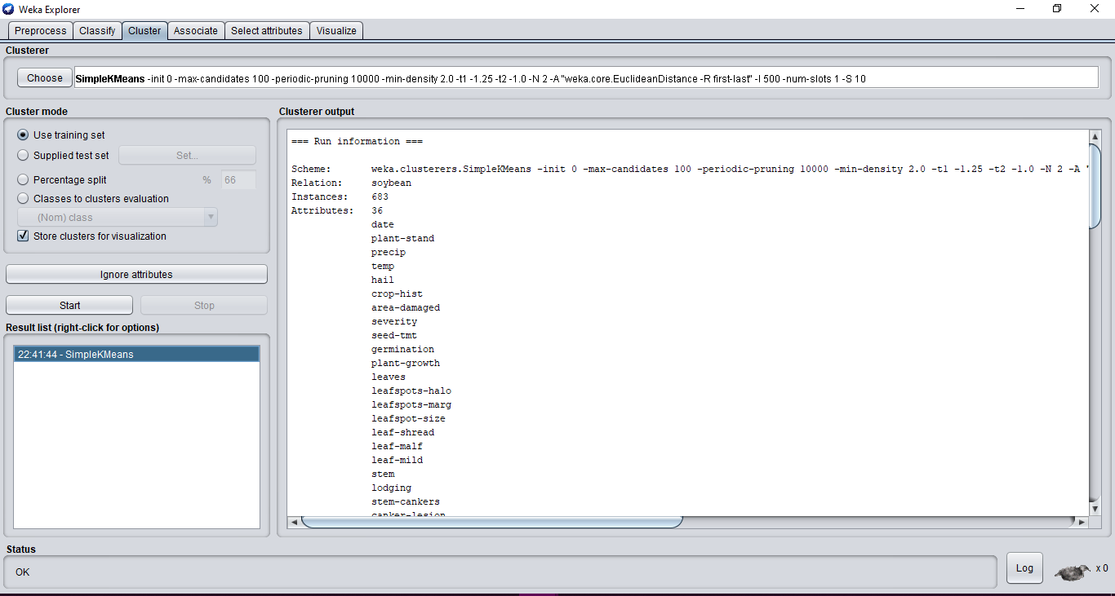h) Go to “**Cluster**” which is used for grouping of the data.

**Initial starting points (random):**

**Cluster 0:** september,normal,gt-norm,norm,yes,same-lst-two-yrs,whole-field,severe,fungicide,80-89,norm,abnorm,no-yellow-halos,w-s-marg,gt-1/8,absent,absent,absent,abnorm,yes,absent,tan,present,firm-and-dry,absent,none,absent,norm,absent,norm,absent,absent,norm,absent,norm,brown-spot

**Cluster 1:** june,lt-normal,gt-norm,norm,yes,same-lst-sev-yrs,whole-field,pot-severe,none,lt-80,norm,abnorm,no-yellow-halos,w-s-marg,gt-1/8,present,absent,absent,norm,yes,absent,dna,absent,absent,absent,none,absent,norm,absent,norm,absent,absent,norm,absent,norm,brown-spot

**Final cluster centroids**:

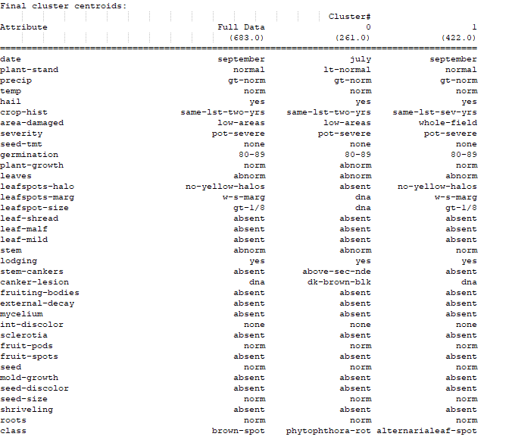

Clustered Instances:

0 261 ( 38%)

1 422 ( 62%)

i) Go to “Associate”. Choose ‘Apriori’ and click on "start" to build the model.

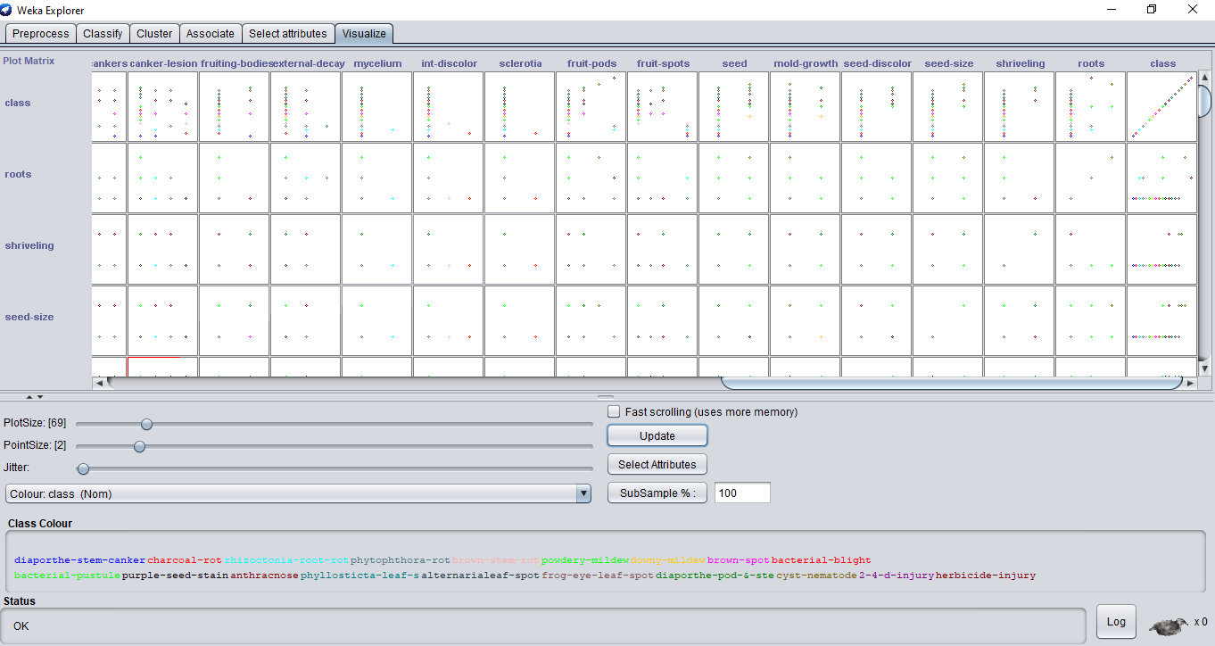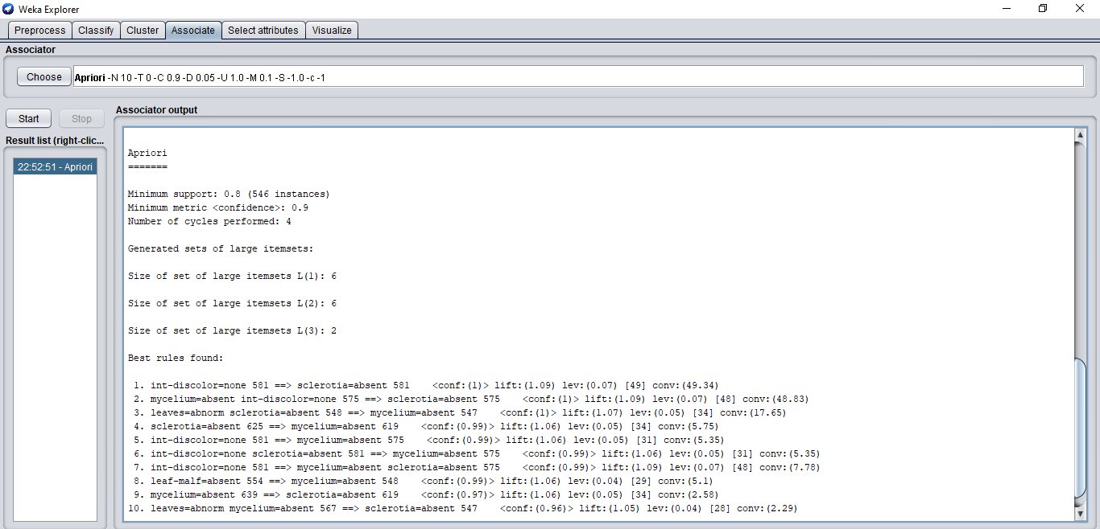j)Go to “Visualise” for checking and visualizing the entire data.